**IMT 540: DESIGN METHODS FOR INTERACTIVE SYSTEMS**

**FINAL DESIGN REPORT**

**Pills on Track**

**Group 5**

Kevin Wen

Ruchika Mulchandani

Vanshika Shrivastava

**EXECUTIVE SUMMARY:**

Pills on Track is an app to deliver correct medication and provide timely reminders to take the medication with an aim to be technologically easy to access by older adults (aged 60+). Having the medicines delivered to the users will be an offline process triggered by the doctor’s clinic and pharmacy, along with onboarding associated patients to the app. From the end user’s (older adults’) perspective the app supports functionalities to view the medications prescribed to them along with the schedule, settings to choose their preferred mode of receiving medication reminders, receiving and responding to medication reminders and a provision to contact the app’s helpline for any required assistance. Additionally, the app provides optional monitoring to ensure that the user has consumed the right medication and this is done via video proctoring.

**INTRODUCTION TO THE DESIGN PROBLEM:**

About 83.6% of all older adults aged 60 to 79 in the U.S. use at least one prescription drug (CDC, 2019), nearly 80% take at least two, and 36% take five or more (Ruscin & Linnebur, 2022). PillPack is a service by Amazon which allows users to order medicines based on their prescription and PillBox is an app that provides reminders to users to take medications based on the reminders set by them. Knowing how it may be difficult for older adults to take their medications on time, we decided to focus our project on an app that combines both PillPack and PillBox, a prescription delivery website and a medication reminder app, as no such aggregate app exists yet. However, technology can sometimes be challenging for older adults, and we aim to tackle this issue via our app.

Pills on Track is meant to combine both delivery of the correct medication and providing reminders to take it at the right time. This app can be used by a patient who has medical insurance and visits a clinic that is partnered with this app. We assume that the user has the app set up on their phone with assistance from the doctor’s clinic. Shared details between the doctor and patient will also take care of the medicines’ delivery to the patient. We will be using a scenario-based paradigm that concerns a specific population of older adults (aged 60+) with the end goal of ensuring that they take medicines at the right time. We provide additional features to assist with ensuring that the right medication has been taken and a means to escalate issues via a helpline.

**Design question:**

How do we assist older adults (aged 60+) to take their medication on time via simplified technology?

**RESEARCH STRATEGY:**

Our research comprised of 3 types of research strategies

1. **Task Analysis** done based on the result of contextual enquiry with a PillPack user to understand how the current PillPack service works.
2. **Contextual Interview** of 3 people above the age of 60 to understand and observe the process of how they currently take their medication, introduce our app’s idea to them and take into consideration their expectations from such an app. We paid special attention to the pain points they encounter while taking their medication currently, and the pain points of their interaction with devices and apps.
3. **Competitor Analysis** of other services that assist with medicine delivery and apps that assist with medicine consumption reminders. We paid attention to the features they currently support and gaps in their user experience.

**RESEARCH RESULTS:**

**Result of Task Analysis:** [(LINK to zoomable image)](https://drive.google.com/file/d/1A9mKd3UdnG4hceUxV_Ty55C5W0PxNs5Y/view?usp=sharing)

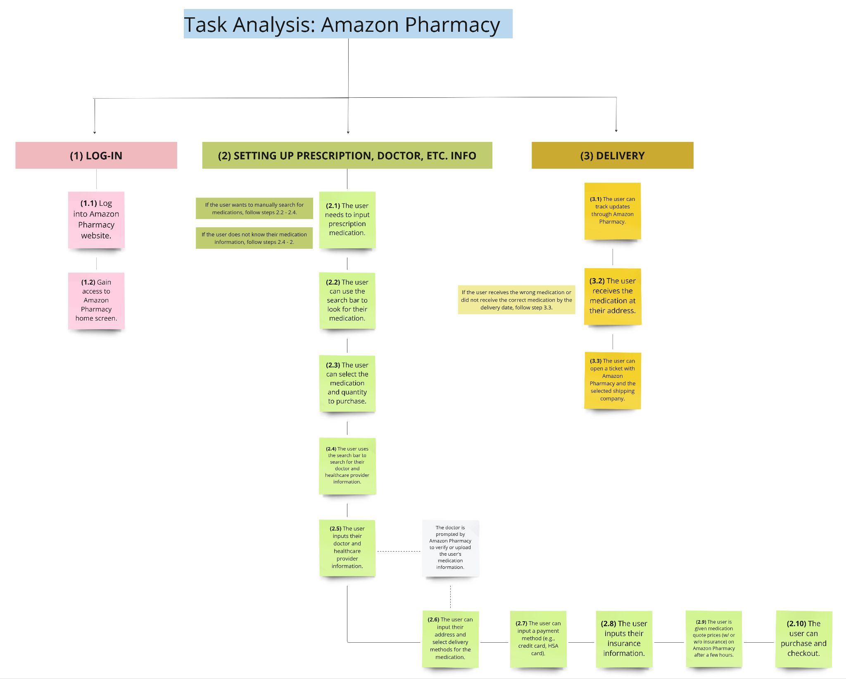

**Additional points to note:**

1. The user can buy their medication whenever they need it, but there are limitations set to how much medication they can buy by the nature of the prescription and medicine type (e.g., once a month).
2. Users can add the medication to their cart and choose either to purchase with or without insurance.

**Result of Contextual Interviews:**

Scenarios created based on user interviews of people above the age of 60 who take medications on a regular basis:

As-is: Scenarios for medicine consumption without the app’s assistance

1. User is reminded by family members to take the medicines
2. User has the medicines delivered to them or in some cases picks it up themselves
3. User carries the medication with them at all times
4. User receives packed medications from the pharmacy as per dosage
5. User is able to read medical prescriptions and take the pills correctly
6. User is not able to read medical prescriptions
7. User is not comfortable with using technology devices

To-be: Scenarios for medicine consumption with the app’s assistance

1. User should be able to inform the app that the medication has been taken
2. User should be guided by the app via visual descriptions about the medication to be taken
3. App should remind the user to take the medicines using descriptive messages and alerts either via text, voice or wearable gear
4. App should notify the user about the medication being delivered via either text messages/ in-app notifications / phone call/ wearable gear
5. App should be able to check on the users if they are taking medications properly and accept user feedback.

The collective pool of these scenarios has given us an insight into a complete set of features that our app should accommodate. The ‘as-is’ scenarios mentioned above are not all integrated in a technological platform. Our app aims to account for all of these suggested features and some potential improvements.

**Result of Competitor Analysis:**

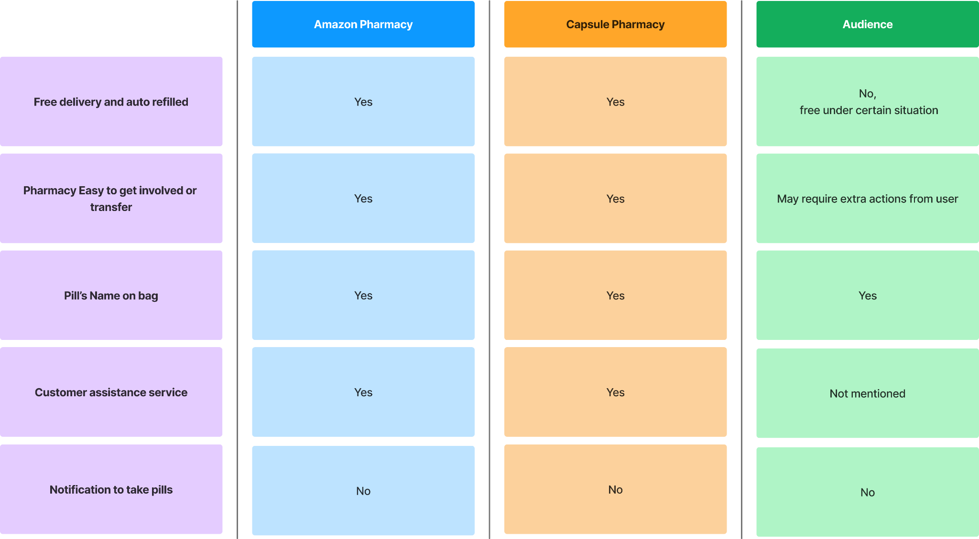

**Collective Results:**

Our research has led us to gather the following insights:

1. The app can have a similar support or contact feature as that of Amazon pharmacy, not only with the pharmacy, but also with their healthcare provider or doctor. This feature can be used if there is an issue with or the user has questions about their medication.
2. Prioritize the design to focus on the ease for users to onboard and engage with the App.
3. Prioritize the ease for users to receive reminders.
4. The app should have a convenient user interface to account for technological accessibility for people above 60 years of age.
5. User pool may have different requirements about how they want the app to engage with them (via text, call, wearable devices, voice messages, etc). The app should be able to provide sufficient support to accommodate preferences of all users.
6. App should provide some flexibility for users to set some preferences about receiving reminders

**KEY REQUIREMENTS, ASSUMPTIONS AND CONSTRAINTS:**

**Requirements:**

1. Users have basic knowledge of interacting with a smart phone for simple processes like clicking a button.
2. The app should have a straightforward and user-friendly interface, with prominently legible text and buttons, while also incorporating capabilities for voice commands and other accessibility functions.
3. Apps should allow users to distinguish or be informed about detailed information about their medications, including dosage instructions and name of the medicine, and detailed time to take the medicine.

**Assumption:**

1. User has health insurance
2. The user has basic tech proficiency to interact with a doctor/ pharmacy through an app.
3. The user has signed up. App has been set up by the doctor’s clinic entering user specific details and medicine schedules.
4. The medicines have been delivered to the users.
5. Users agree with our information privacy policy and trust we would protect their information.

**Constraints:**

1. **AccessibilityProblem:** Despite an easy interface, elderly people may only have little understanding about using smartphone apps due to limited tech proficiency.
2. **Cognitive limitation:** Elderly people may have troubles when trying to read or interact with the app due to their physical limitations.
3. **Data and information privacy:** We are using approaches such as voice confirmation and video proctoring due to which we need to be very careful about customer’s information security.

**CONCEPTS AND PREFERRED APPROACH**

Since our main design goal is to help elderly users to take the correct pills at the right time, our main users would be old people, we have to consider a lot of problems about usability and accessibility. As a result, we realize that easy to read and easy to use is very important.

Our main approaches are:

1. allow users to check their daily medicine schedules

2.Send notification to them when it’s time to take the pill.

3.During the time when they are taking pills, we would offer help to make sure they are taking the correct pills.

Our recommended solution based on a user-centric approach is a **Pills on Track App** that can cater to the needs and limitations of the target population (older adults). This app consists of following features:

* **Wearable Technology Integration:** To offer discreet medicine reminders, the app synchronizes with wearable technology, such as activity trackers or smartwatches. Wearable technology enables users to discreetly receive alerts, guaranteeing they never miss a dosage.
* **Notifications from the App:** There are many notification settings available inside the app. Reminders can be sent to users via text and audio alerts. Users can receive reminders in their favorite language or dialect using adjustable language options.
* **Visual assistance:** The app includes visual assistance to improve medication management. Within the app, users may view pictures and descriptions of the medicines they are prescribed. This feature helps older adults recognize and comprehend the dosing instructions for their medications with ease.
* **In-App Helpline and Contact Number:** The app gives priority to user support and help. It has an in-app helpline option that users may use to get prompt support or information about their prescription. Users can also phone a special hotline in case they have any inquiries or complaints.
* **Voice assistance:** The app will announce the medicine details and actions to be taken by the users to guide them through their user journey. This will be supported in a language of their choice.

**PROTOTYPE DESIGN**

Based on our research insights, we first made a wireframe for our products. Next, we made a high fidelity prototype based on our wireframe.

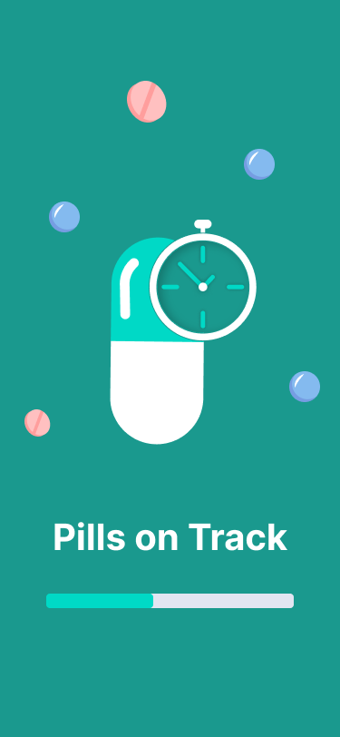

Splash screen displayed when the user opens the app. It has a progress bar to indicate that the app is loading.

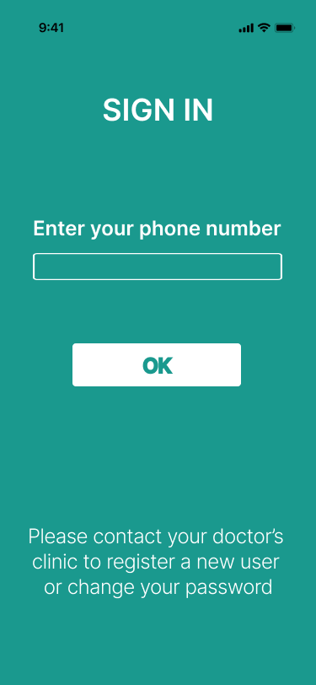

After becoming a Pills On Track user, during the login phase, the only thing our user needs to do is enter their phone number. We will automatically match your number with your pharmacy information and upload all the information to the app for our user.

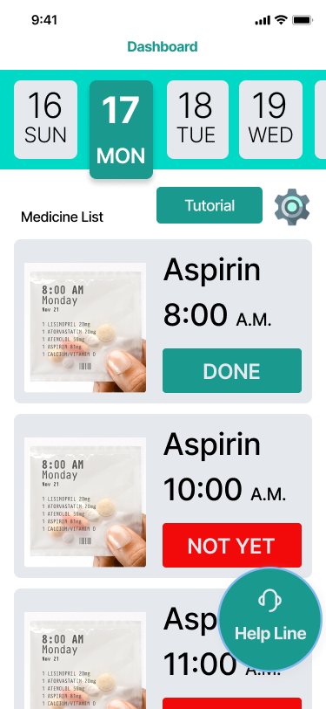

The dashboard is the landing page after the user logs in. It displays:

1. Dates
2. Medicine details and schedule
3. Button for Settings
4. Button for Helpline
5. Button to view the Tutorial

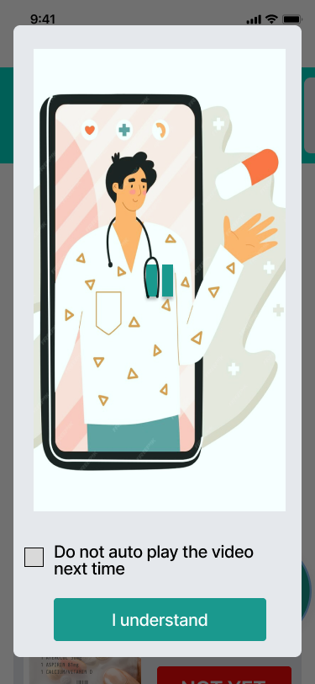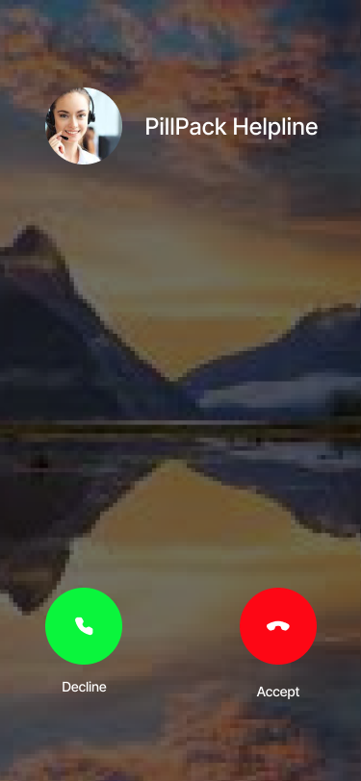

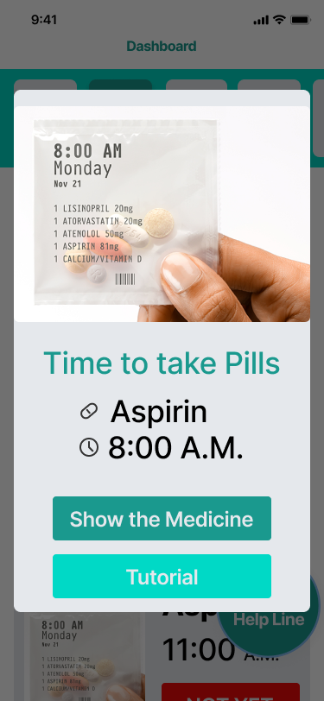

Screen displayed to remind the user to take the medicine if the user has enabled consent for video proctoring. It also announces the description of the medicine, for instance: “ It is 8 am. Please take one Aspirin. It is yellow in color and round in shape.”

If ‘Tutorial’ is clicked, a tutorial is displayed showing the user how to scan the medicine.

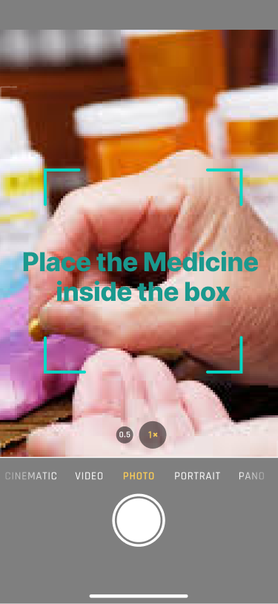

Screen displayed to prompt the user to show the medicine they are consuming. Voice assistant announces “Scan the medicine. Place the medicine inside the green box.”

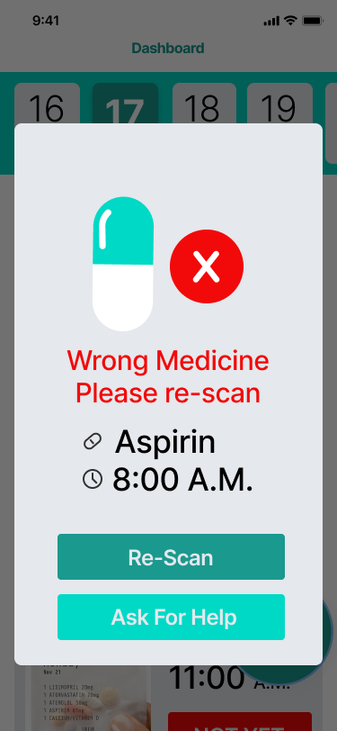

Screen displayed when the scanned medicine is incorrect. The user is prompted to rescan the medicine. Voice assistant announces “Wrong medicine, scan again.”

If the user decides to ‘Ask for Help’ , the helpline will be called.

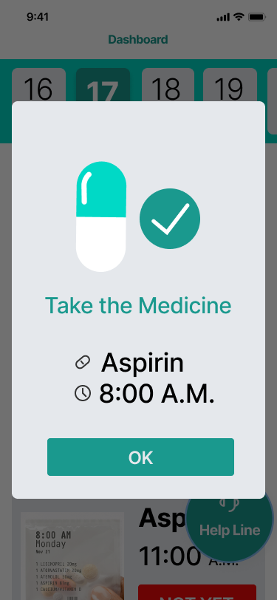

Screen displayed when the scanned medicine is correct. Voice assistant announces “Take the medicine”

This is also the reminder screen when the user has not opted for video proctoring. In this case the voice assistant announces the description of the medicine, for instance: “ It is 8 am. Please take one Aspirin. It is yellow in color and round in shape.”



Screen displays the tutorial to the user.

The tutorial is also auto played every time the user opens the app. The checkbox allows the user to disable auto-playing of the tutorial.

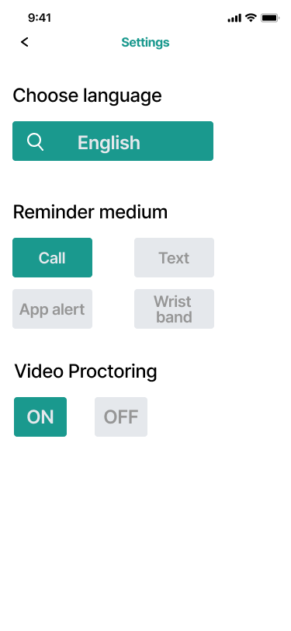

Settings page allows the user to choose their medium of reminder and language. We support all languages supported by Google’s voice assistant.

The settings page also allows the user to opt for video proctoring

Reminder mediums apart from the ‘App alert’ function as follows:

1. Call: The user receives a call from the app’s call center to take medicines at the scheduled timings

2. Text: The user receives a text messages describing the medicine details, at the scheduled timings

3. Wrist band: The wristband buzzes at the scheduled reminder timings to take the medicine. In addition, the wrist band also announces the description of the medicine, for instance: “ It is 8 am. Please take one Aspirin. It is yellow in color and round in shape.”

**STAKEHOLDER FEEDBACK:**

**Feedback Strategy:**

We conducted interviews with three older adult users showing them the app prototype and describing the functionalities. The feedback received from them provides valuable insights into the Pills on Track app prototype. While two users express high satisfaction with the app's functionality and concept, the third user highlights concerns related to technology dependence.

**Interviews:**

**Stakeholder 1:** The "Pills on Track" app has exceeded my expectations in managing my medication schedule. The interface is incredibly intuitive, making it easy for me to navigate without encountering any confusion or difficulty with features. Personally, I find the app alerts to be the most effective reminder method, providing timely notifications that are clear and easy to understand, complete with detailed information about my medications. The wristband alerts have been a game-changer, enhancing my experience with discreet reminders on my wrist.

**Stakeholder 2:** I am really happy with the "Pills on Track" app concept; it has really given me a sense of freedom in managing my medicines. The idea that I can rely on the app to effectively handle the schedules of my medication is relieving. It gives me more control over my health since I don't need other people to constantly remind me of things.

**Stakeholder 3:** I must admit that my experience with the 'Pills on Track' app will leave me somewhat dissatisfied, primarily due to the level of technology involved. While I understand the intent to streamline medication management, I will find it challenging to be reliant on my phone or wearing a wristband constantly for alerts. It will not be practical for me to carry my phone everywhere, and wearing a wristband consistently will feel uncomfortable. I wish there was an option for the app to allow the use of both the phone and the wristband simultaneously. This way, if I'm not wearing my wristband or don't have my phone on hand, I could still receive crucial medication alerts. A more flexible approach in terms of technology integration will make the app more accommodating to users like me who will not be entirely comfortable with constant device dependence.

**FUTURE DESIGN WORK:**

**Feedback analysis:**

The feedback suggests us to enable an additional mode of receiving reminders where wristband and mobile phone alerts can be used simultaneously. Though enabling this will help people who do not keep their phones with them at all times but do wear the wristband, it can also become irritating. Key points:

1. The addition of this feature needs to be well thought off so as to not frustrate the users.
   1. Alert on both the phone and wristband only if the distance between them is more than 1 meter. If the distance is less than 1 meter, alert on the wristband alone.
   2. Responding to the alert on any 1 device will automatically silent the alert on the other device as well.
2. This feature will allow us to expand our app to an additional user group - differently-abled people, especially those with hearing and visual impairments. Vibrating wristband alerts with instructional audio/graphic alerts on the phone can help us assist them with medicine reminders in formats that are easy to understand.

**Next Stage of Design:**

The next design phase of Pills on Track will prioritize thorough research and prototyping, with a particular emphasis on accessibility for those with disabilities and guaranteeing extensive user adoption. Particular areas of interest include:

**User Research:** Conduct user research, including surveys, interviews, and focus groups to understand the requirements and preferences of differently-abled people. Explore how features that combine the use of the phone and wristband for reminders can assist those with visual or hearing impairments.

**Prototyping:** Design prototypes keeping in mind the preferences and requirements of people who are differently-abled. Functionalities including phone-based visual alerts, voice alerts, and vibrating wristband notifications should be tested and improved thereby ensuring that people with a range of impairments may easily utilize and benefit from these features.

**Continuous Improvement:** Having iterative design to develop the new product feature that serves a wide range of user requirements.

**User Adoption:** Giving wide user adoption a priority demonstrating a dedication to developing a feature that not only satisfies the requirements of people with disabilities but also appeals to a large user base. This is in line with the objective of improving the app's usability and inclusivity for all users.